# 📘 My English Hub Children Starters

Hi! My name's Katty. I'm your teacher.

What's your name? ................................................................

**Life in colours!**

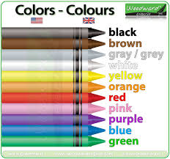

Now, you paint....

The pencil is black and yellow  The pencil case is purple 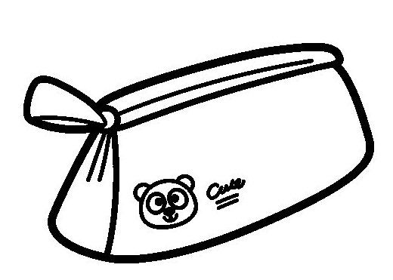

The rubber is red and blue 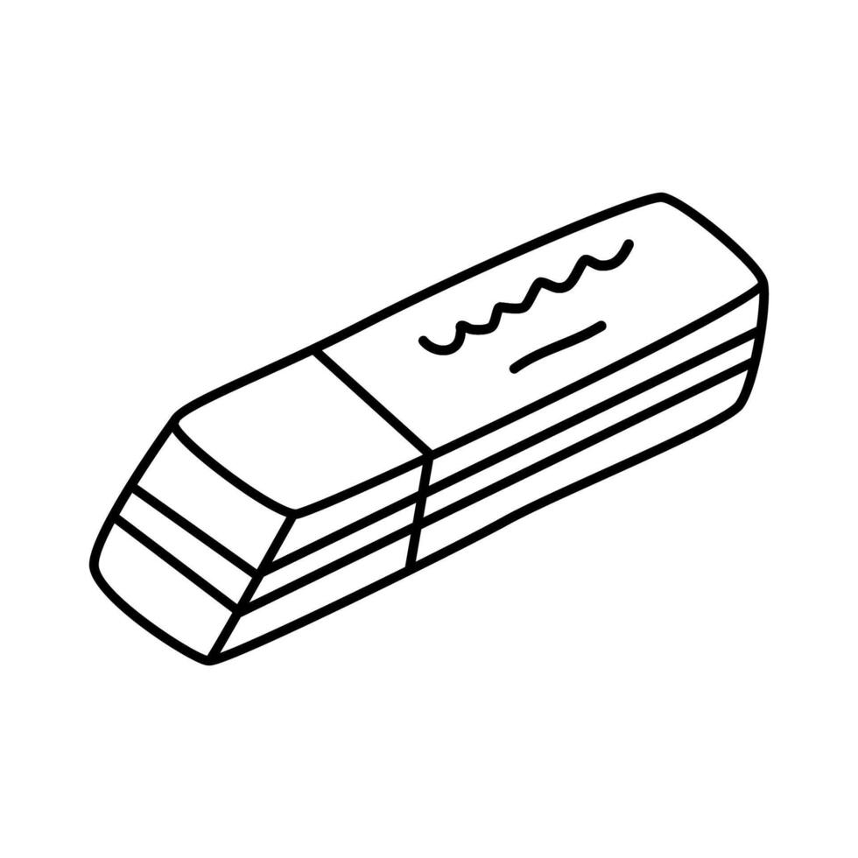 The chair is brown 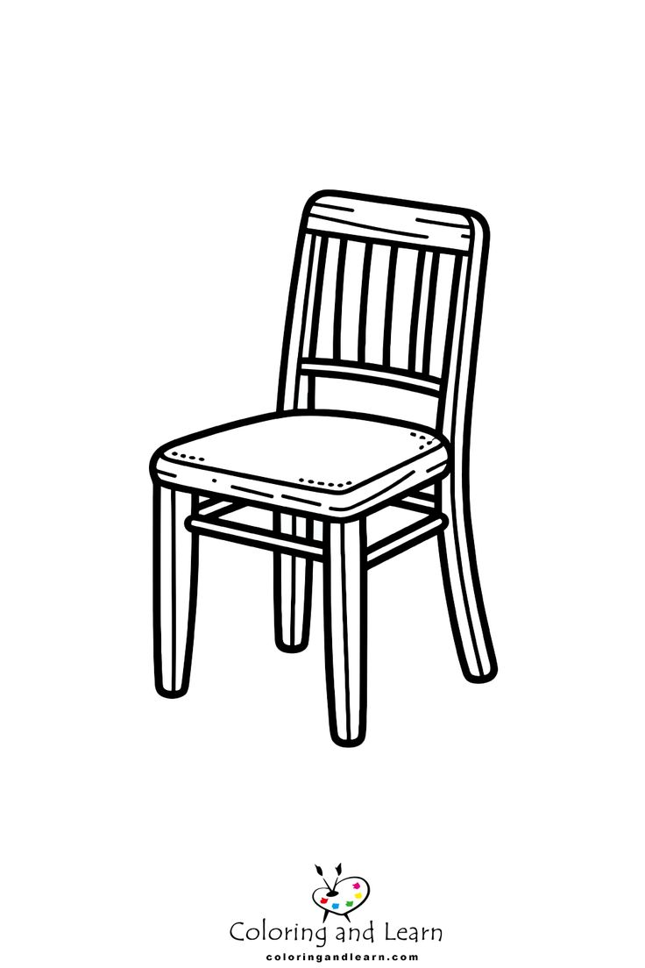

The scissors are green 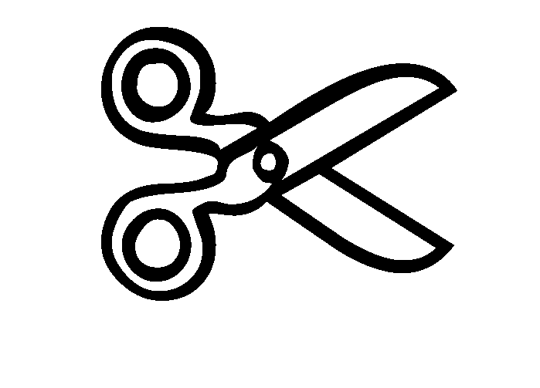 The book is orange 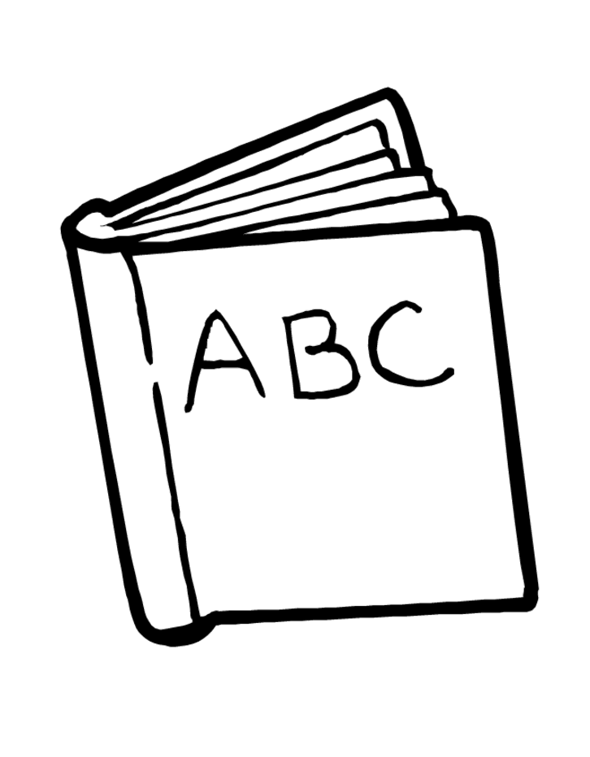

The schoolbag is grey 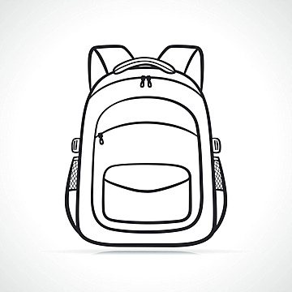 The desk is pink. 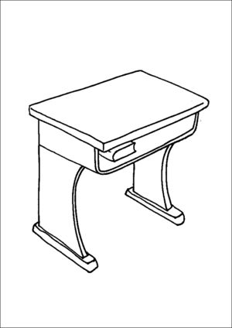

**Life in numbers!**

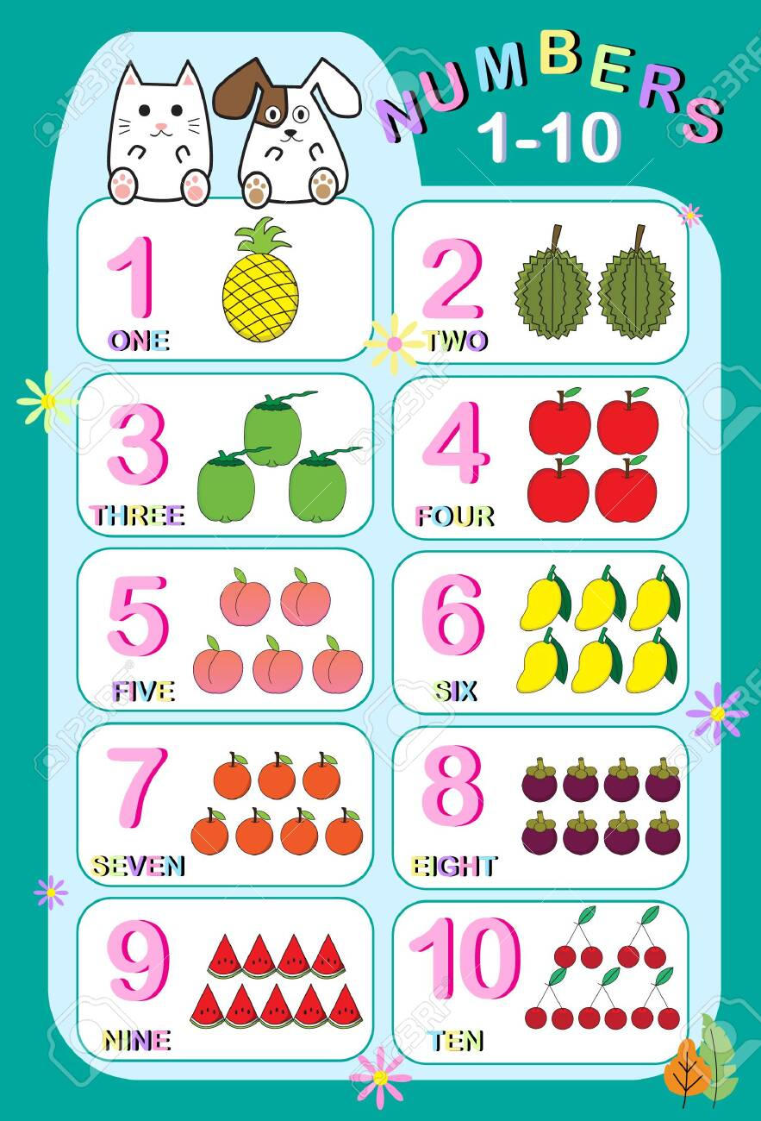

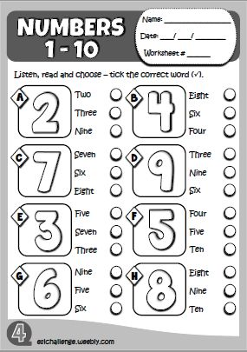 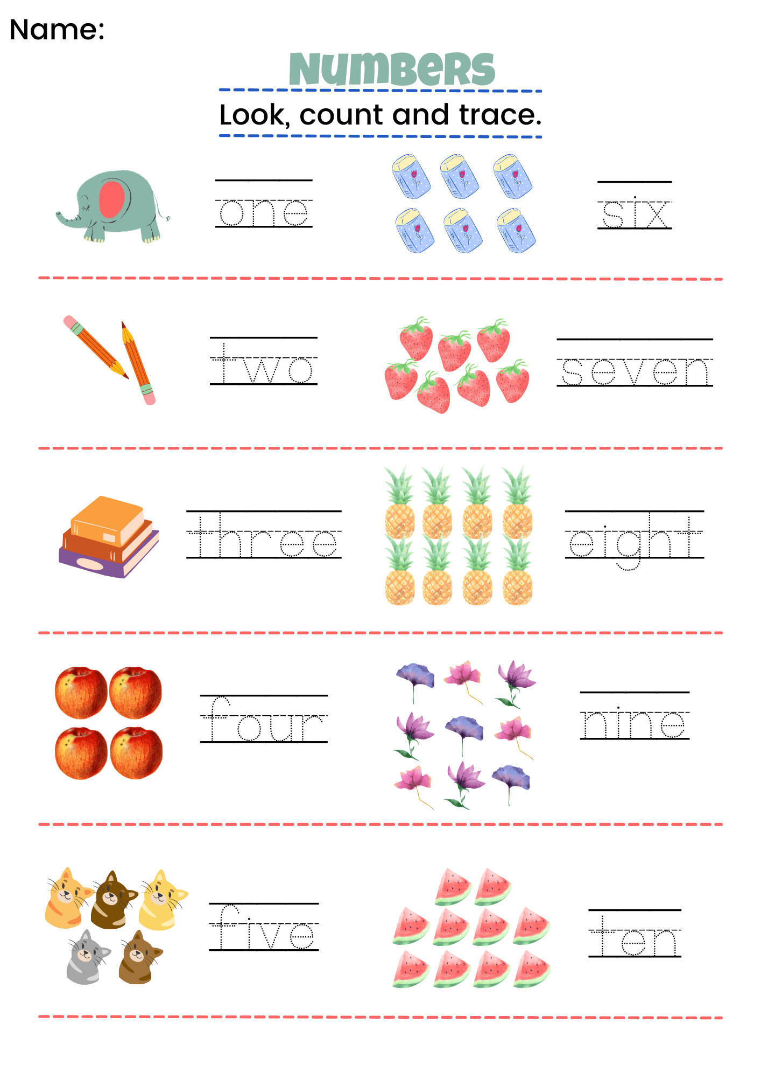

**Now answer**:

1. What colour are the computers?

They are ............................................

1. How many computers are there?

There are ...................... computers

1. What colour are the rulers?

It is ................................................

1. How many rulers are there?

There is ................ ruler.

**Life is us!**

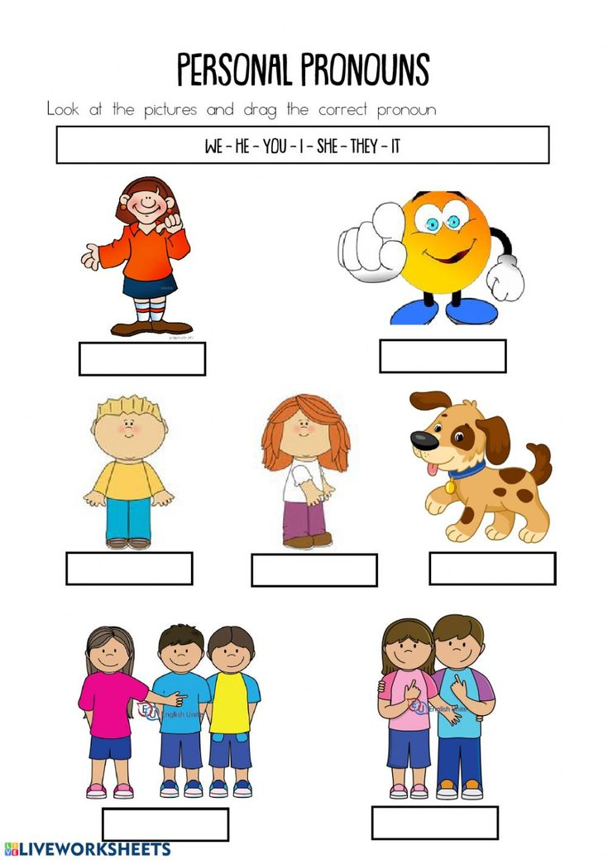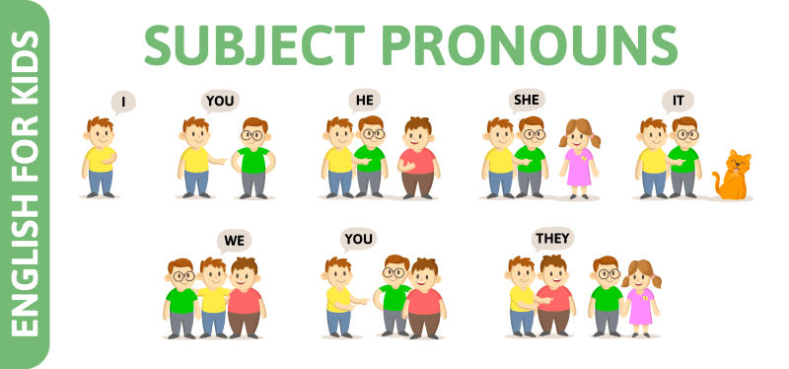

**In Spanish**

I = yo

You = vos y Ustedes

He = el

She = ella

It = esto, eso

We = nosotros

They = ellos, ellas.

**Are you happy today?**

**Verb to Be:**

**In the present:** Now, today, this week, every day, always, usually, on weekends

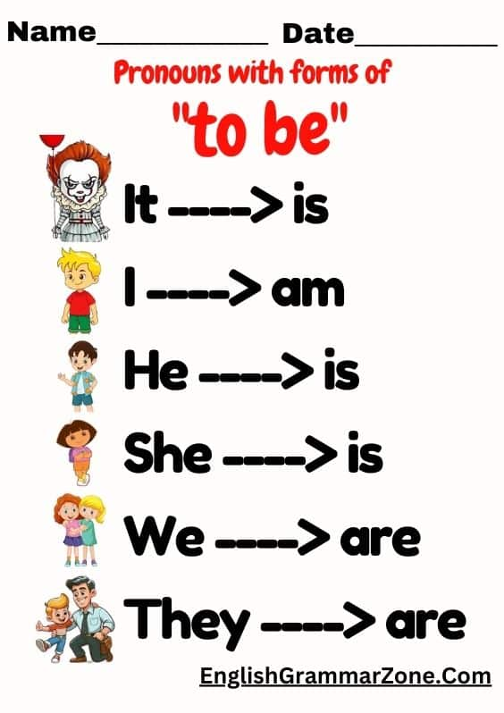

|  |  |  |  |  |
| --- | --- | --- | --- | --- |
| **Subject** | **Affirmative (+)** | **Negative (-)** | **Question (?)** | **Short Answer** |
| I | am a student | 'm not a teacher | Am I a student? | Yes, you are / No, you aren't |
| You | are a student | aren't a teacher | Are you a student? | Yes, I am / No, I'm not |
| He | is a student | isn't a teacher | Is he a student? | Yes, he is / No, he isn't |
| She | is a student | isn't a teacher | Is she a student? | Yes, she is / No, she isn't |
| It | is a car | isn't a car | Is it a car? | Yes, it is / No, it isn't |
| We | are students | aren't teachers | Are we students? | Yes, you are / No, you aren't |
| They | 're students | aren't teachers | Are they students? | Yes, they are / No, they aren't |

## 📲 ¿Querés seguir aprendiendo?

👉 Consultá por el próximo nivel Children  
👉 Escribinos por WhatsApp para recibir ayuda  
👉 ¡Sumate a My English Hub y seguí avanzando!